FLOOD MONITORING AND EARLY WARNING

610221106022 : RAMYA.S

Phase 5 submission doucument

Project Title : Flood Monitoring And Early Warning

Phase 5 : Project Documentation & Submission

Topic : In this section you will document the complete project and prepare it for submission

Introduction :

Flood monitoring and early warning systems are essential components of disaster management aimed at reducing the risks associated with flooding. These systems involve the use of various technologies, data collection methods, and communication networks to anticipate, monitor, and forecast potential floods. The primary goal is to provide timely and accurate information to communities, governments, and relevant authorities to mitigate the impact of flooding and save lives.

**Importance of Flood Monitoring and Early Warning:**

**Introduction :**

The impact of global warming prompt decision making authorities to enhance flood-risk management processes to address issues related to the causes of floods. Risk mitigation can be done simultaneously with multiple factors [1]. Floods occur when water levels of rivers exceed and there is sea rise during heavy rains. A very common natural disaster that affects the lives of people, and private and public properties are floods, especially in inhabited areas but in urban and rural areas, this could jam road networks disrupting commuters from reaching their destinations. Although the flood rescue teams from the local government units provide support to the people using different communication channels, the dissemination of flood related information needs to be conveyed quickly. Humans have been trying for a long, but not always have been fully successful in controlling and foiling the destructive consequences of floods. Synthetic flood banks have been made and river courses have been straightened. Further, the riverbed is deeply dredged. These methods are effective but likely to have adverse effects on the river habitat.

**Risk Mitigation:** Floods are among the most common and devastating natural disasters. Timely warnings help communities prepare, evacuate, and take necessary precautions to minimize the impact on lives and property.

1. **Community Safety:** Early warnings give people the opportunity to seek safety, move belongings to higher ground, and take necessary measures, reducing the risks to life and property.
2. **Infrastructure Protection:** Monitoring and warnings also assist in safeguarding critical infrastructure such as roads, bridges, and utilities, reducing damage and facilitating faster recovery.

**Components of Flood Monitoring and Early Warning Systems:**

1. **Monitoring Stations and Sensors:** These systems utilize a network of sensors, gauges, and monitoring stations to measure various parameters such as rainfall, water levels, river flow, and soil moisture.
2. **Data Collection and Analysis:** Information from monitoring stations is collected, analyzed, and processed using various technologies and modeling techniques to predict and understand flood patterns.
3. **Forecasting and Warning Dissemination:** Advanced forecasting models based on historical data, weather patterns, and real-time information are used to predict potential flood events. Warnings are then disseminated through various channels, such as mobile alerts, sirens, radio, television, and social media.
4. **Community Preparedness and Response:** Education, community engagement, and preparedness plans are crucial elements. Information on how to respond to warnings and evacuation procedures is provided to citizens to ensure a swift and effective response.

**Challenges and Advances:**

1. **Data Accuracy and Availability:** Access to accurate and timely data is critical. Advances in remote sensing and satellite technology have improved data collection and accuracy.
2. **Communication Infrastructure:** Ensuring that warnings reach all at-risk populations, including remote or underserved areas, remains a challenge. Improvements in communication networks and technology have helped address this issue.
3. **Climate Change Impact:** Changing weather patterns and increased frequency/intensity of extreme weather events pose challenges to existing models. Continuous adaptation and improvement of these systems are necessary.

Early Flood Warning :

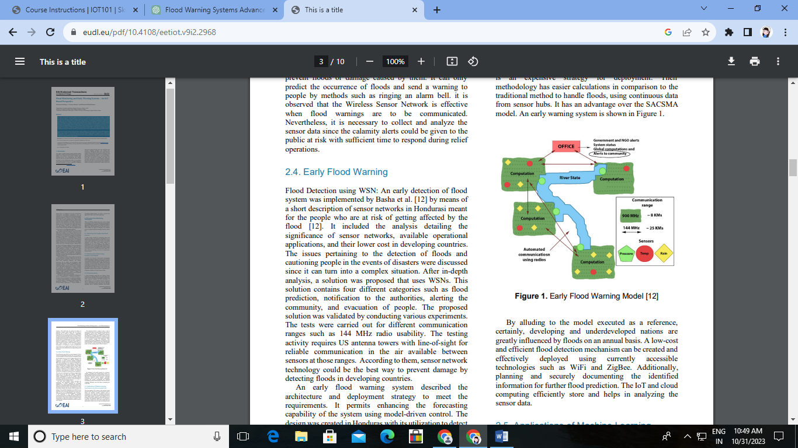

**The implememtation of an IOT-Based Flood Alert System :**

A system to detect inundation stages by measuring the upsurge in water levels and alerting local residents was proposed by Shah et al. [20]. The waterfall model as a methodology with Raspberry Pi was used to gather information from deployed sensors which transmitted it to the Global System for Mobile communication (GSM) module. The system further would alert the resident by sending an SMS as an outcome. As quoted by the author, researchers have estimated that if the sea level rises by 4 inches by 2030, it could be a reason for dangerous flooding that could be affecting many parts of the world. There is an emphasis on the usage of the GSM module since there is an increment trend in the usage of mobile users have been positive. This makes it easier for the system to alert authorized people when in an emergency. This system followed a waterfall model and discusses the use of different technologies as mentioned below. The authors used a water sensor, SEN113104 model, and USB 3G modem Huawei mobile broadband E173.

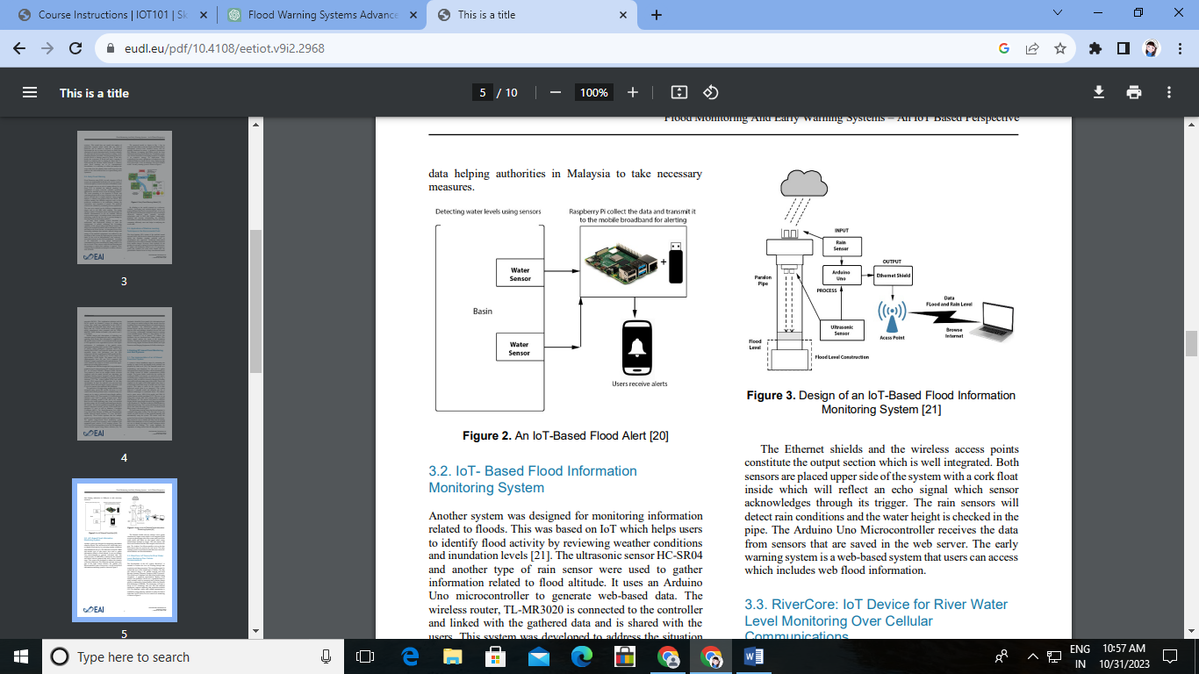

**RiverCore : IOT Device for River Water Level Monitoring Over Cellular Communications :**

Development of the IoT system “RiverCore” is intended to monitor the river for flooding through data acquisition and data processing. This was imp

lemented for a particular area of the Colima state of Mexico. The data was retrieved using a 3G cellular network and used Message Queuing Telemetry 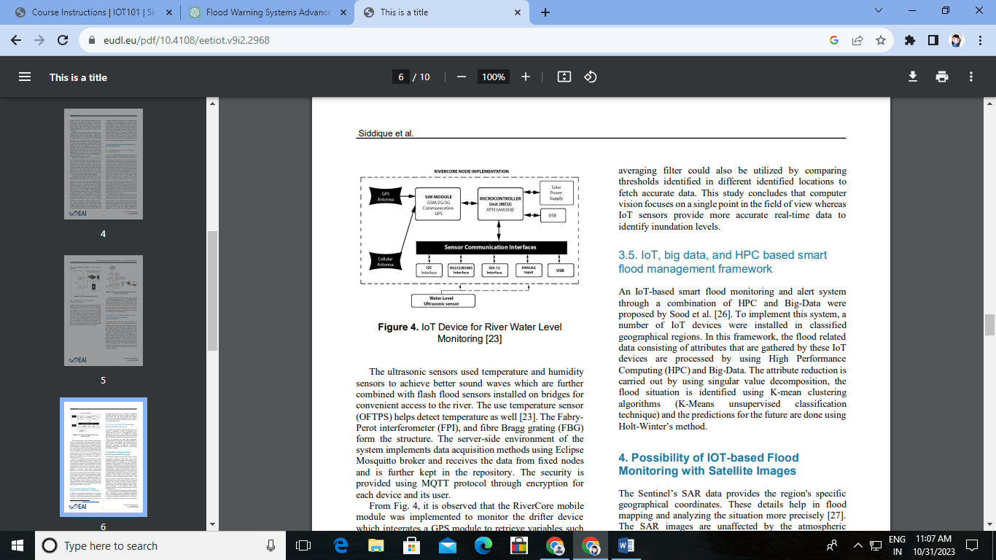Transport (MQTT) protocol.

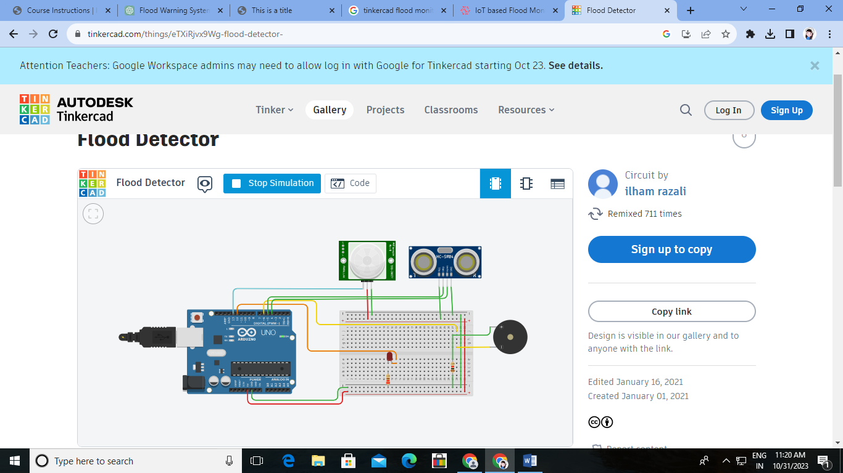

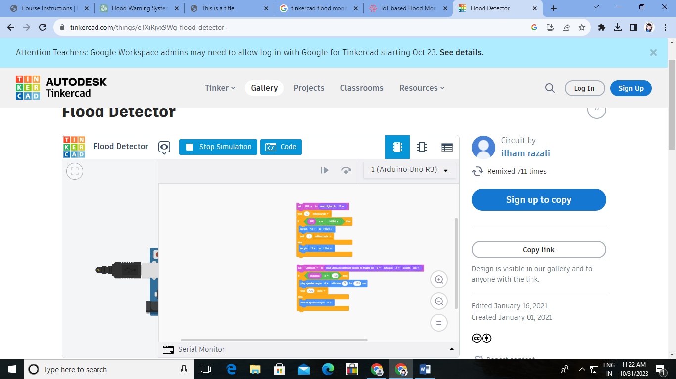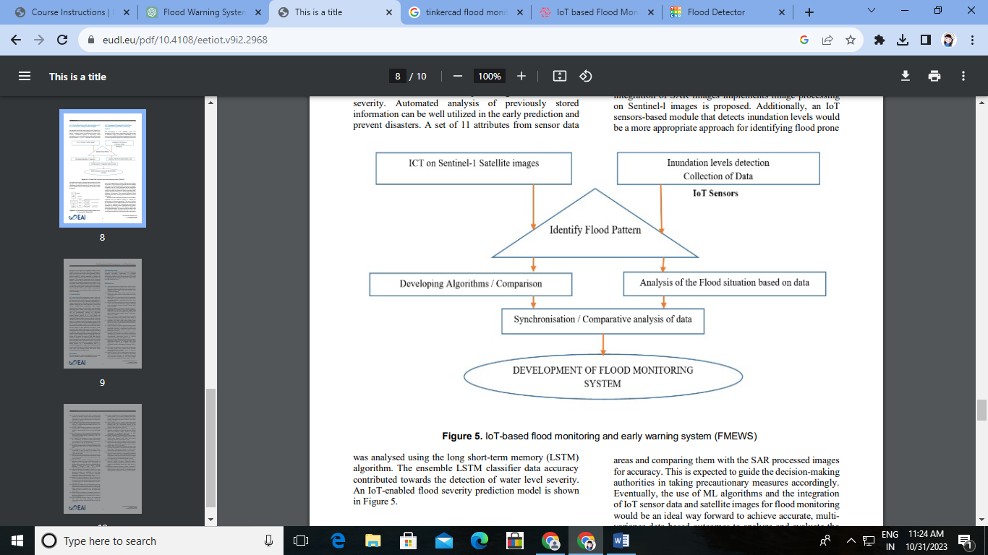

**Conclusion :**

IoT sensors-based flood monitoring systems tend to be lower cost, consistent and portable. However, when there are large areas, these systems are not recommended due to the fact that every sensor is generally invigorated by a vitality restricted battery

Link : https://www.tinkercad.com/things/eTXiRjvx9Wg-flood-detector-